**TABLE OF CONTENTS**

|  |  |  |
| --- | --- | --- |
| **Sl NO.** | **CONTENTS** | **PAGE NO** |
|  | **ABSTRACT** | 1 |
| **1** | **INTRODUCTION** | 2 |
|  | 1.1 PROJECT DESCRIPTION | 3 |
| **2** | **PROPOSED SYSTEM** | 4 |
|  | 2.1 MODULE DESCRIPTION | 4 |
|  | 2.2 HARDWARE AND SOFTWARE REQUIREMENTS | 5 |
| **3** | **SCREENSHOTS** | 6 |
| 4 | **CONCLUSION** | 10 |
| **5** | **BIBLIOGRAPHY** | 10 |

**ABSTRACT**

We use so many applications in our day-to-day life . These applications can be in any format. They can be text files , images , videos , apk’s etc,. The storage of the files is very trivial and it is important to store all these files and documents in a concise and ordered manner so that they are accessible very easily when you want to access it the some other time.

Our project “The File Manager” aims to solve these problems . Using our project you can be able to store , move, rename , delete , open , cut , copy , paste any of these files on the device.

The best part of this File Manager is that it is totally offline i.e. There are no advertisements or pop-up’s whatsoever . Moreover , the UI is very user friendly and Comprehendible .

1. **INTRODUCTION**

These days Device storage is a major issue for Smart Phone User because we get limited storage which are either covered by multimedia or other apps which lacks space for important stuffs. Security is also a concern for storing Any Important Files or documents in Mobile Phones as. The Data which are stored in Mobile Phones are not safe as it’s not that hard to hack a phone or a virus to destroy it or damage or theft; any situation the user loses the files. So, we introduce **Android File Manager** it’s a totally Server based system it means you can store any type of file on cloud server. This is an advance system which provides the facility to store and retrieve the files without any duplication or if there is it alerts the user for further action. In case of large amount of files, the user can take the advantage of manual search or text to speech feature to the system to filter out certain files.

**1.1 PROJECT DESCRIPTION**

* The file manager that already exists i.e. in the market have a lot of ads and pop-ups , various promotions that sometimes maybe annoying.
* Not all features of the file manager are free , so you are supposed to buy it’s premium version
* Our project aims in solving these problems . The file manager that we have created is completely free and it’s totally offline that is no more annoying pop-ups or ads !
* The interface is very convenient and comprehendible.

**PROPOSED SYSTEM**

2.1 MODULE DESCRIPTION

The “File Manager” is used to store and organize data in an effective and organized way.

It has features like :

* Rename : It renames already existing files.
* Delete : It is used to delete unwanted files.
* New Folder : It is used to create a new folder to store files in it.
* Move/Cut : It is used to move files from one folder to another.
* Copy & Paste : It is used to create a copy of the file and paste it to a required destination.
* Refresh button.

2.2 HARDWARE AND SOFTWARE REQUIREMENTS

**HARDWARE REQUIREMENTS**

**Developing Environment**

* Ram 4GB
* Processor Intel Core i5
* Hard disk(space) 40GB for developer
* Keyboard and mouse Required

**Client Environment**

* Hard disk(space) 30GB
* Ram 512MB
* Processor Pentium IV or above.
* Monitor 15 VGA Colour.
* Internet Connection Not Required

**SOFTWARE REQUIREMENTS**

**Developing Environment**

* Operating system Windows 10
* Coding Language Java
* Tools Android Studio.

**Client Environment**

* Internet Not Required.
* Browser Not Required.

1. **SCREENSHOTS**

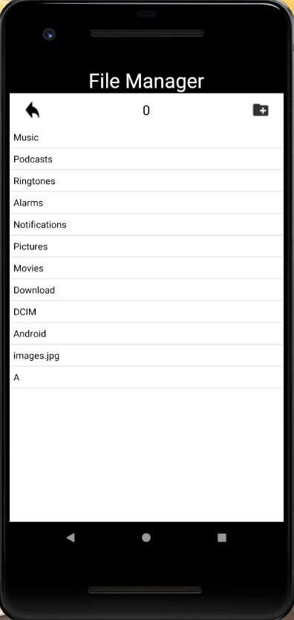

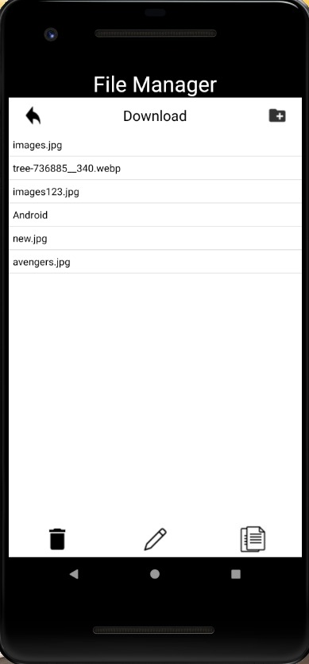

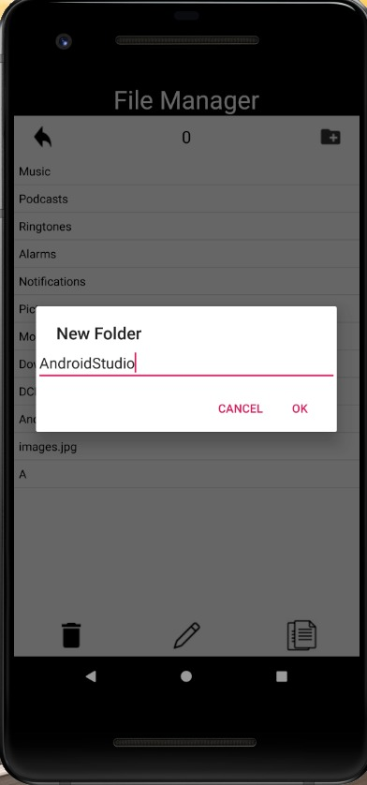

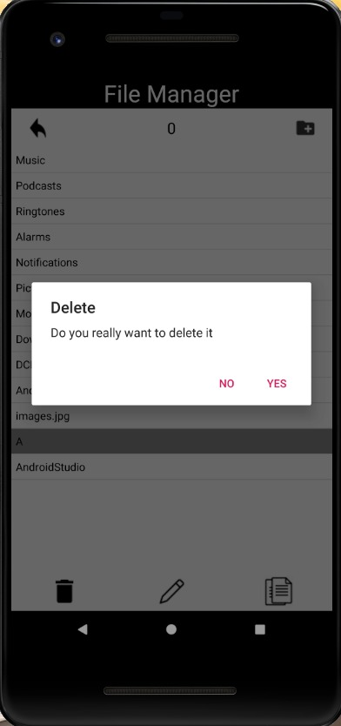

1. **CONCLUSION**

All things considered the “File Manager” is a very useful and a must have application in every mobile phone. It maintains the files in a categorized and ordered manner.

It saves both time and memory which are most important factors that decide the well being of the electronic gadget.

**BIBLIOGRAPHY**

Websites Referred

1. [www.github.com](http://www.github.com)
2. [www.naveonprojects.com](http://www.naveonprojects.com)
3. <https://jerrybanfield.com/>

